Pupils Support Program
I was travelling to Sumbawanga from Mpanda via Sitalike- Kizi road which crosses Katavi National park, through Lyamba lya mfipa mountain slopes and the open land that buffers the park (north), Lwafi Game reserve (east) and Mpimbwe Wildlife Management Area (west), when our minibus broke down, and there, all the passengers evacuated to wait for a mechanic to replace the spare tyre. While I was wondering at that wild open place, I suddenly saw a young boy roaming around, nearby our minibus! I could not hold my wish to ask what the boy wanted from us. “How can I help you boy” I asked the boy! My mother sent me to ask whether there is somebody wants to buy our charcoal! Charcoal? Yes, the boy responded! Where is the charcoal? “There” (the boy responded), pointing at one of the pit which was about 30metres beside the road! Why do you burn charcoal? “I asked!” “we have no alternative income source, we have finished all our harvests made this year, my dad said there is nothing they can do to get money to buy school uniform and exercise books for me and my young sisters” the boy said. 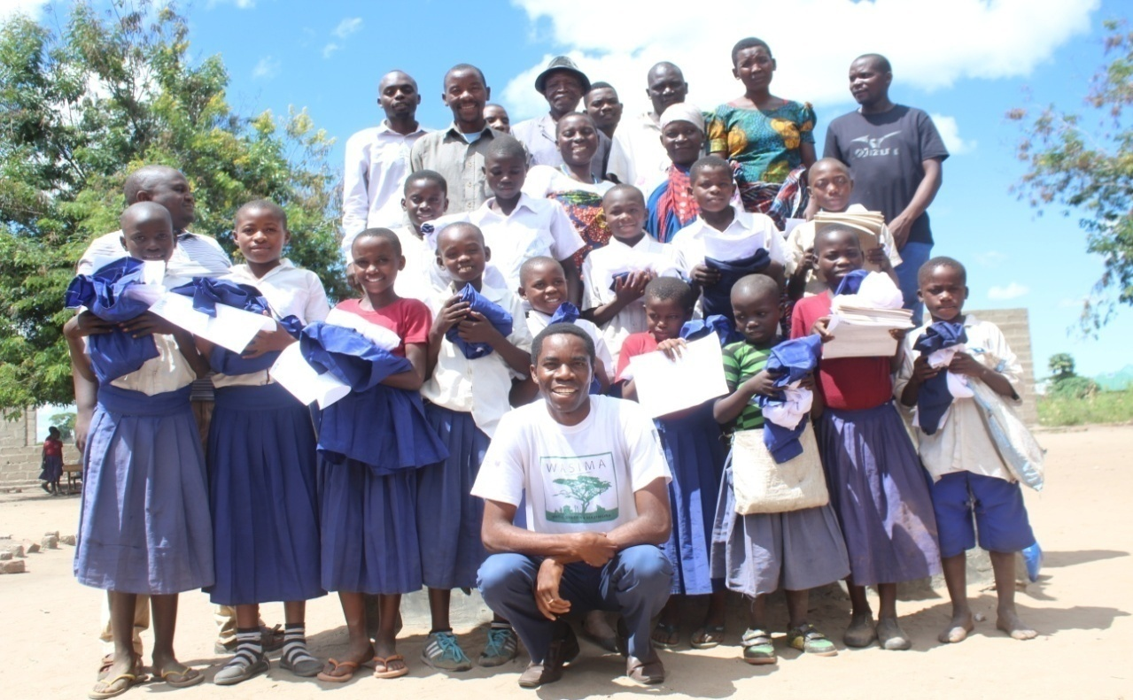
Figure 1: Jonathan in a group photo with program awardees (pupils) and guardians at Luchima village (70km from Usevia , but 0.7 katavi park boundary) .Photo by Charles Ndandala.
I had held suggestions from our lion conservation ambassadors, that we needed to outreach children from families supporting lion hunters and former lion dancers. The two incidences led to the pupils support program, which was first supported by The Sacramento zoo and then Brevard zoo voters and Greenville zoo to reduce poaching pressure to our core reserves.
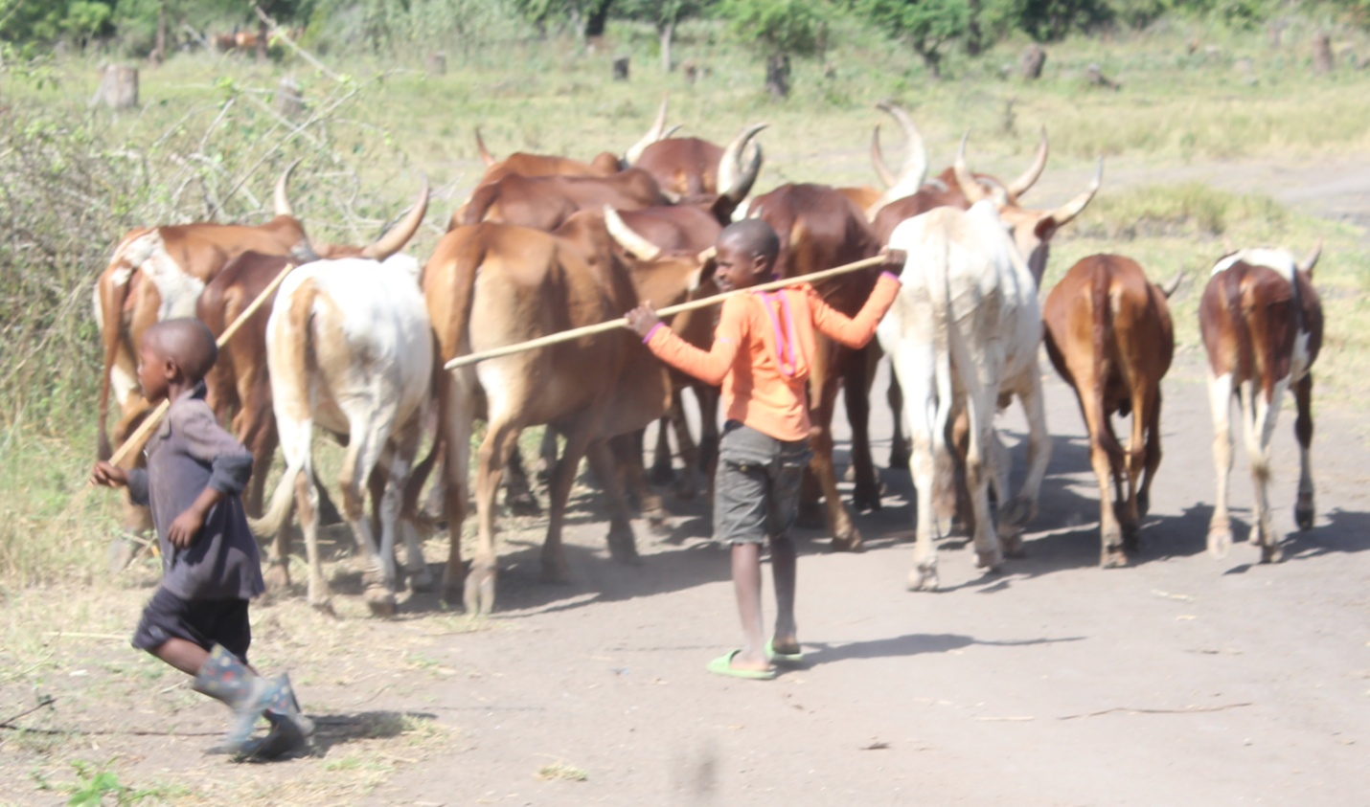
Figure 2: most children from the agro-pastoral sukuma communities are livestock grazers, thsu discouraged from schools and encourage to inherit lion hunting traditions. Photo by Jonathan Kwiyega.
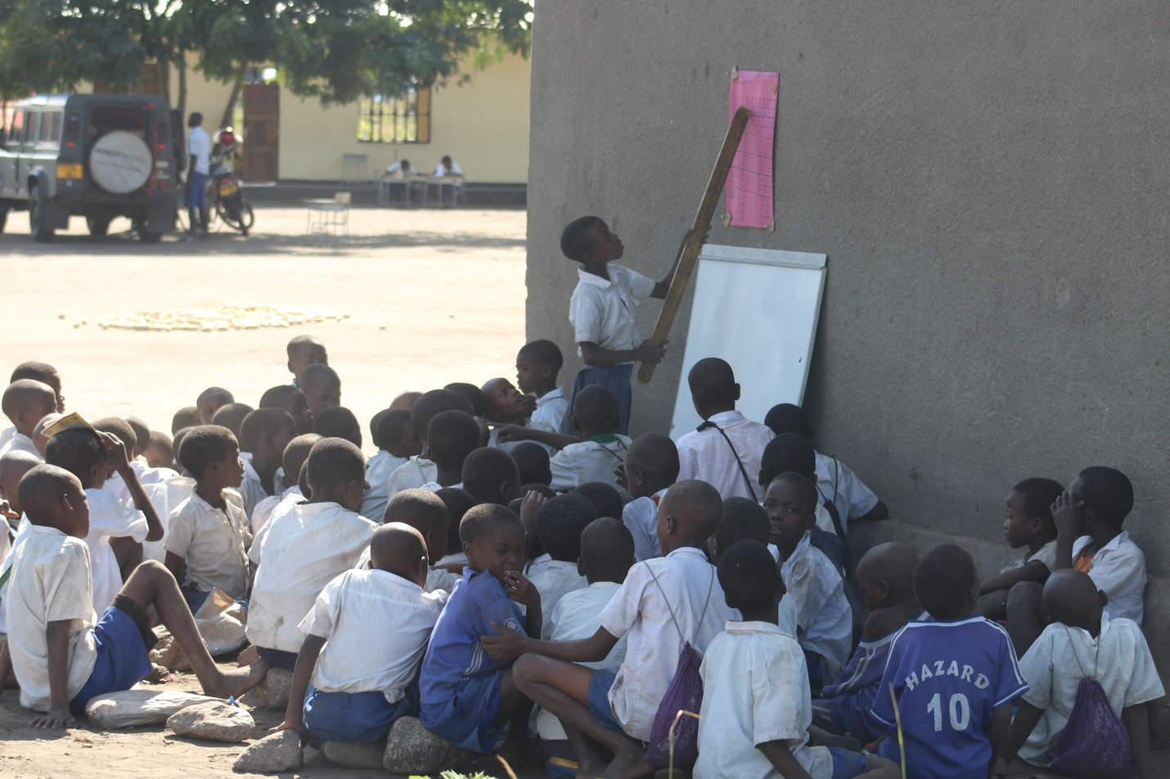
Figure 3: Pupils who happen to go to school, classrooms, books and chairs are not enough. We can do something to inspire children from villages adjacent reserves, whose income sources are just disturbed by predators and problem animals. Photo by Jonathan.
The Pupils Support Program was initiated in 2017 as part of WASIMA campaign to support pupils from families of former lion killers, lion dancers and those rewarding lion dancers. Lion dancers are lion killers who practices tradition lion dance using lion amulets (skin, teeth, nails and manes) as witnesses for killing these livestock predators. The lion dances aims to get prestige as warriors, and thus collect rewards from their family relatives, neighbors and fellow resident members willing to give rewards such as cattle, shoats and cash. Most lion dancers have become wealthy and respected individuals in community as the results of these gifts to the extent of inspiring children and young men and the whole community to have worriers in their family for the purpose of becoming rich. Most locals still believe that lion killers have good fortunes of becoming rich easily and fast, such that locally accepted traditional practices has recently changed resulting into devastating population of lion population within reserves in western Tanzania ecosystem.
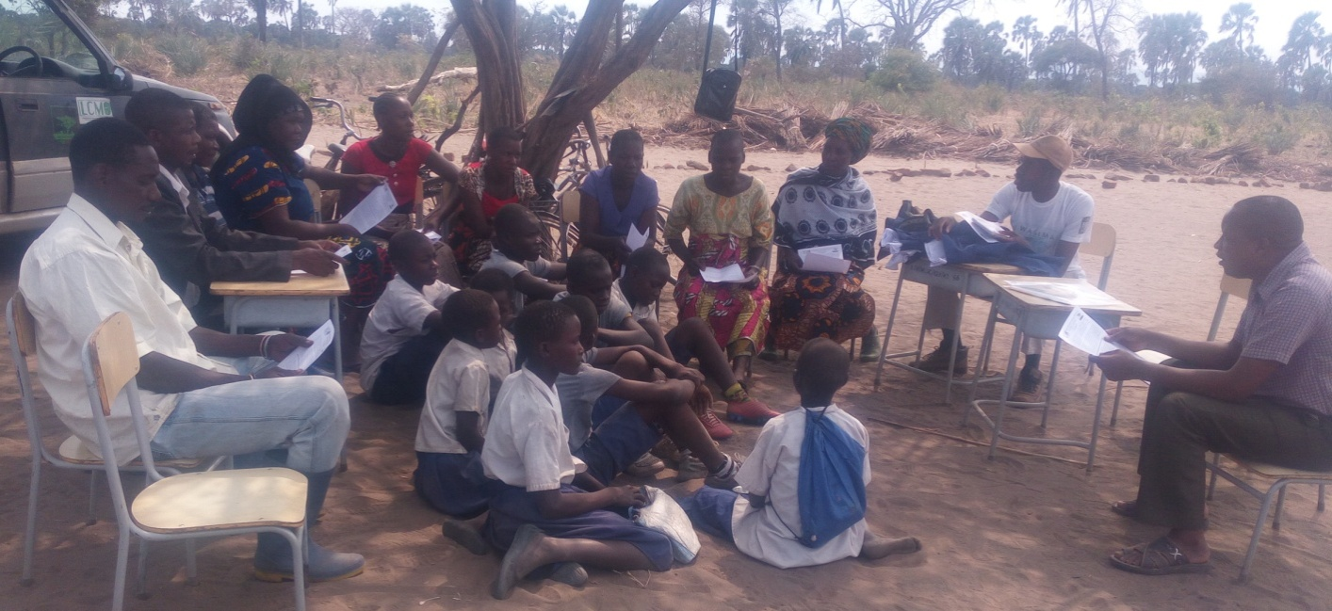
Lion dancers have been a motivation of producing fake lion dancers who illegally hunt lions and dance for rewards and the community is happy to give them gifts. In combination with pupils from marginalized families our aim is decrease the drop out, improve performance, retain pupils in schools and reduce pressure through overdependence to natural resources for livelihood. We know through education the lion hunting mindset diminishes leaving the young generations with new conservation attitude which then produces a wildlife co-existing community. By providing uniforms and class materials to these target families, through this program we are intending to reduce poaching by reducing needs for harvesting charcoal, bush meat, timber and fuel wood so on for the sake of raising cash they would otherwise need to purchase these items. A total of about 300 pupils have benefited from the program between since 2017 todate. The support included school uniforms and class equipment (shirts and trousers, skirts, shoes, pen and exercise books and underwear for girls).
To summarize, the program main objectives include:
- To cut off lion hunting ideology among young generation of lion hunting families and that lion dancing cannot be the only source of wealth and that education is more important for personal and community development.
- To reduce the needs to harvest charcoal, bush meat, timber and fuel wood for the sake of fulfilling their basic needs including school requirements.
- To reduce the burden to parents and guardians whose families live close to reserve boundaries, and to encourage conservation friendly values and practices.
- To continuing supporting both primary and secondary pupils in schools adjacent reserves and help communities understand that the community benefiting from nature through non-consumptive wildlife utilization understand and feel that human-wildlife conflicts happening within communities around reserves end up degrading human livelihoods and that they need support as encouragement to co-exist negative daily wildlife interactions.

- To extend support to other school requirements like sustainable water reservoirs, classrooms, furniture and books.
- To retain children in schools to pursue their life dreams and visions as well as motivate them towards hopeful and conservation passionate community and generation.

